Lab 17– AI for Data Processing: Data cleaning and preprocessing
scripts
The objective of this lab is to enable students to understand and apply AI-
assisted coding tools for automating and enhancing data preprocessing
tasks. Students will:
1. Gain practical experience in cleaning, transforming, and
standardizing real-world datasets with issues such as missing values, duplicates, outliers, inconsistent formats, and noisy text.
2. Learn to leverage AI coding assistants to generate preprocessing
scripts, while critically evaluating and refining the AI-generated
code for accuracy, efficiency, and best practices.
3. Develop the ability to design end-to-end preprocessing
pipelines that prepare raw data for downstream machine learning
and analytics applications.
4. Build confidence in combining human expertise with AI
assistance, ensuring data quality and integrity in diverse domains
such as customer feedback, healthcare, and finance

Lab Question 1: Customer Feedback Dataset
You are given a CSV file containing customer feedback collected from
an e-commerce website. The dataset includes columns: customer_id,
feedback_text, rating, and date. However, the file has many missing
values, typos, and inconsistent date formats.
• Task 1: Use an AI-assisted coding tool to generate a script that
detects and fills missing rating values with the column’s median
and standardizes the date column into YYYY-MM-DD format.
• Task 2: Clean the feedback_text column by removing stopwords,
correcting common spelling mistakes, and converting text to
lowercase using AI suggestions. Compare the AI-generated
preprocessing code with your manually written version.

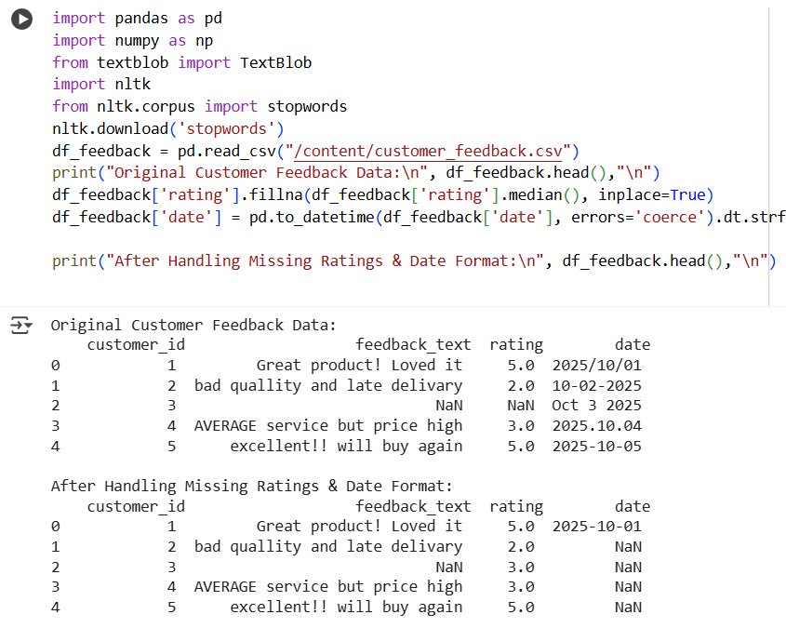
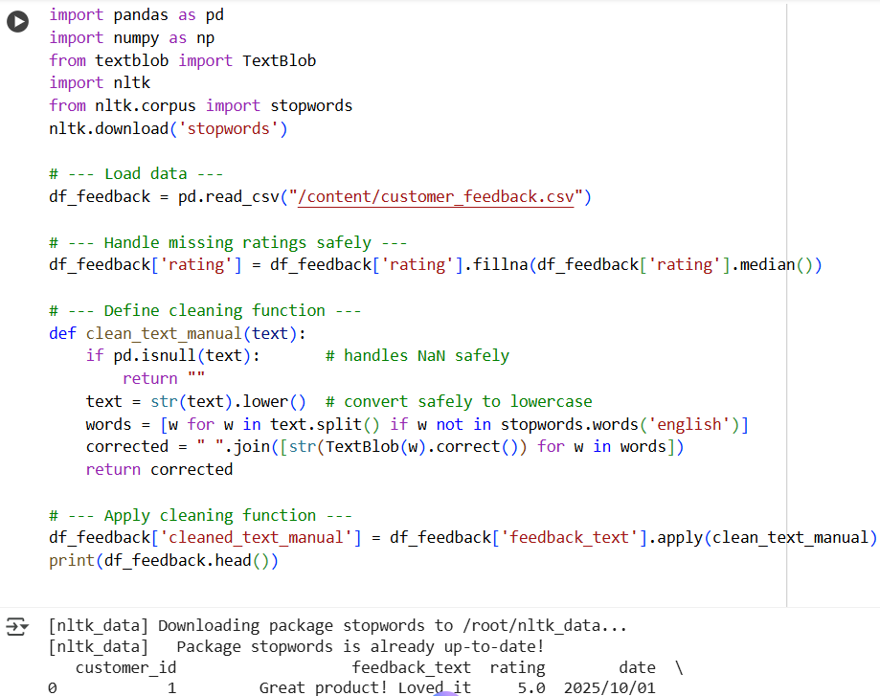

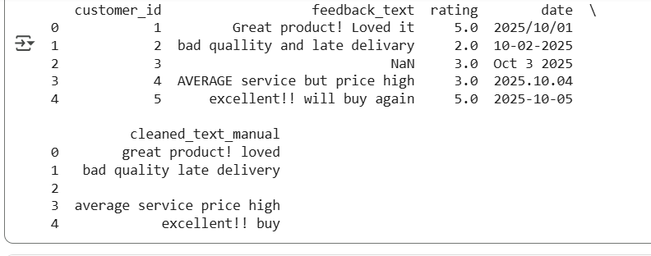

Lab Question 2: Medical Records Dataset
A hospital provides you with a dataset of anonymized medical records
containing attributes like patient_id, age, gender, blood_pressure, and
cholesterol. Some columns include outliers and inconsistent categorical
labels (e.g., Male, M, male).
• Task 1: Write a script (with AI assistance) to detect and handle
outliers in the blood_pressure column using statistical methods
(e.g., IQR or z-score).
• Task 2: Standardize categorical values in the gender column and
encode them into numeric form. Let the AI-assisted coding tool
propose the preprocessing pipeline, then refine the pipeline
manually based on your understanding

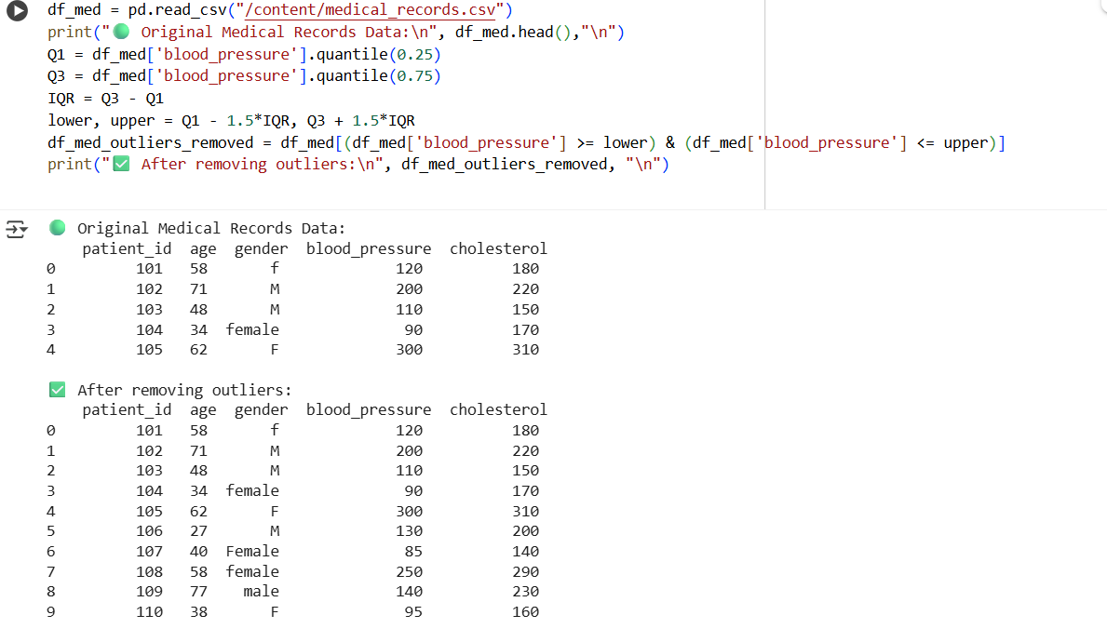

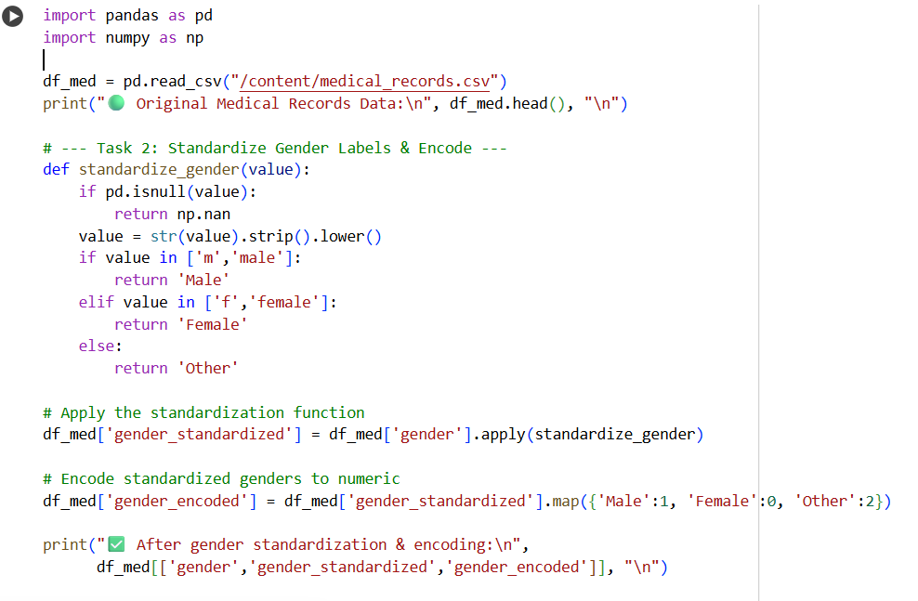

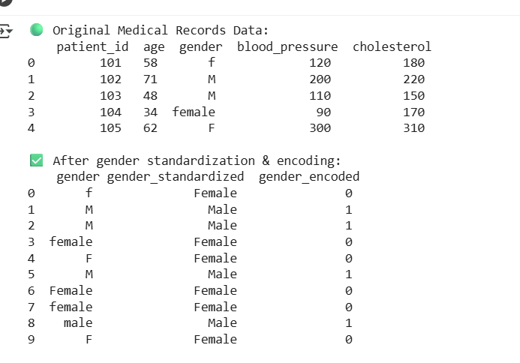

Lab Question 3: Financial Transactions Dataset
A bank gives you transaction data with columns: transaction_id, amount,
currency, timestamp, and merchant. The dataset contains multiple issues:
different currency units (USD, INR, EUR), timestamps in various time
zones, and duplicated rows.
• Task 1: Use AI-assisted coding to write a script that removes
duplicate transactions and converts all amount values into a single
currency (e.g., USD) using a provided conversion dictionary.
• Task 2: Normalize the timestamp column into UTC format and
create a new column transaction_hour for downstream time-series
analysis. Compare the AI’s preprocessing code against your own
optimized version.

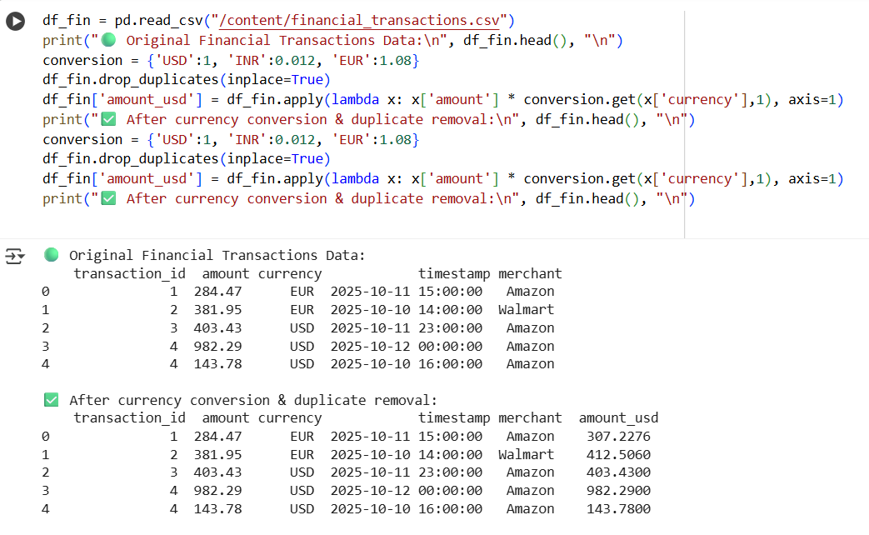

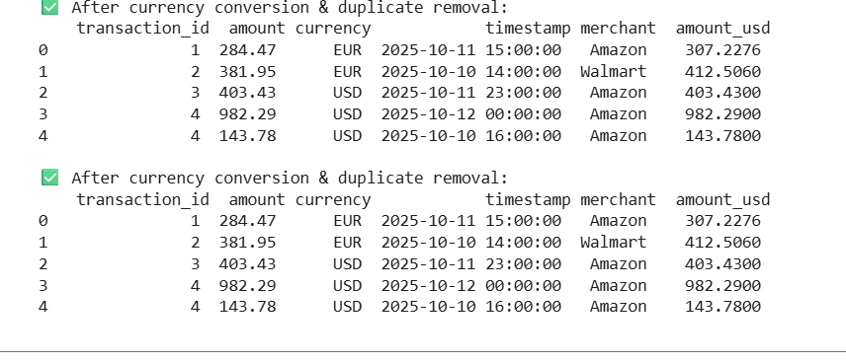

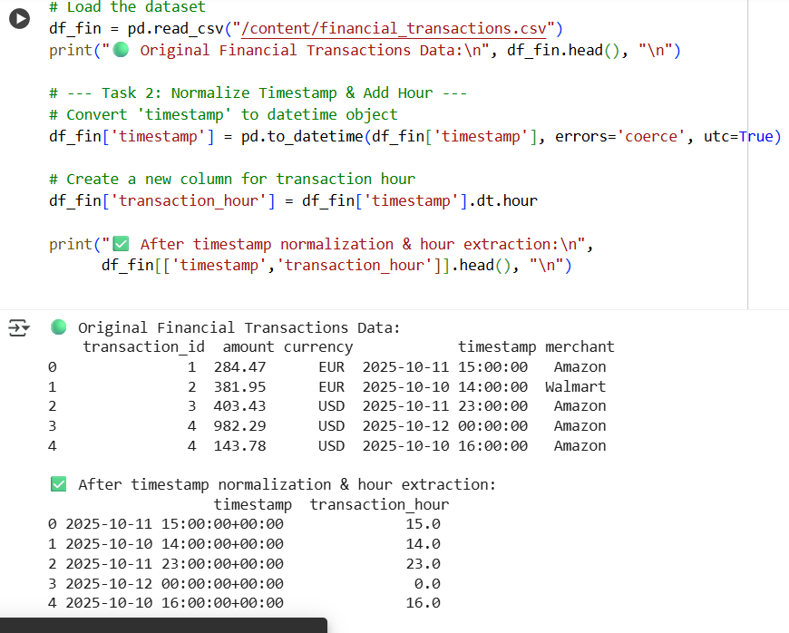

Summary:the ai generated code was fast but not too accurate.where as manual code takes a lot od time to code but even error are prone in manually eritten code also.hence we need to double check both the codes but comparatively ai version is clean,neat and reduces time.But in cases of csv file creation a lot of time is cusumed if we don’t use the help of ai to generate dataset but if we do manually it will be error free

